see for complete information our website  Microdosing of LN2, our #900 series systems  Pressureless dosing of Liquid Nitrogen | Norhof  Binnenweg 40  3604AD Maarssen  the Netherlands  tel (00-31)-(0)-346-575058

NORHOF LN2 MICRODOSING SYSTEM series #900 and #800
Precision controlled administration of smaller amounts of LN2, from dripping up to 1 liter/minute
- Variable flow, controlled by setting, sensors(s) , remote signals or computer.
- Pressure-less flowing LN2, without spilling, noise, vibrations etc.

Norhof manufactures cooling systems in which Liquid Nitrogen (LN2) is used as the cooling medium. LN2 is supplied without any pressure and filling an application is like a teapot filling a teacup.
The flow is variable and can be optimized to the application.
Flow control is on the system itself or by remote signals. With one and the same system the flow range is from
- dripping for e.g. maintaining a certain subzero temperature
- to full flow for filling e.g. a small Dewar
The majority of our systems find use in the field of scientific instruments, physical laboratories, research centers etc. where precise control over subzero temperatures is required or where a LN2 flow of appr. 1 L/min is sufficient. Industrial systems with 15 L/min based on the same principle are also available.
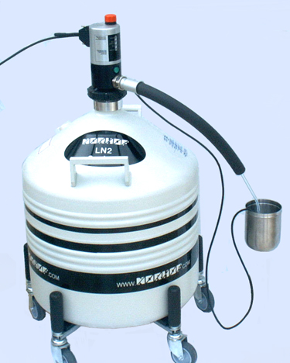
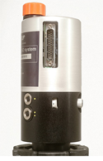

picture shows pump,
mounted on a 35 Liter dewar

possible dewars are 35 or 50 Liter

pump can be used on other type dewars as long as the dewar has a NW50 flange

total system height 79 cm
*insulation of fill-line not shown here

Application
Our autonomous cooling systems are designed for use in an instrumentation environment (e.g. scientific instruments) and/or in processes that require perfect control over the "cold" required.
Liquid Nitrogen (LN2) is used as the cooling medium and is taken from a storage vessel by a static pump and delivered through a fill line to the application in a micro dosing way.
One may view our technique as a cold generator with a temperature range from ambient to -196°C and with a controllable capacity. This capacity (= flow) can be adjusted by hand directly on the pump or by remote signals.
The system is designed to overcome the drawbacks of LN2 under pressure in which a solenoid valve is used to switch the supply ON / OFF. Our system instead delivers LN2 like tea out of a teapot: without any pressure.

Software included
With each system software is included to display "what's going on inside the system". Although each system works autonomously, a PC screen is great to understand and to see "what's going on", and to write history.
For detailed information, and example setups, look at our website.
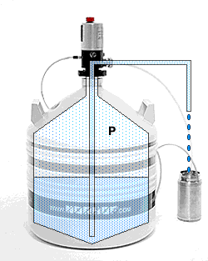
Working principle

The pressure above the liquid level inside the dewar is built by heating a small amount of liquid in the bottom of the dewar.
With only up to 100 mBar of overpressure, the liquid will gentle rise out of the rise pipe and fall into the fill hose.

The pressure above the liquid level is carefully controlled and therefor the flow.

Because we evaporate some LN2 to build pressure, there is no adding of ice inside the dewar, such as with manual systems which use air from the environment.

In the Norhof LN2 cooling systems Liquid Nitrogen is stored in pressure less Dewars. When LN2 is required, a small overpressure is generated by a small heater element in the LN2, and liquid flows out of the system like water from a tap, without spilling, noise, vibrations etc.

Models
Presently there are more models to choose from:
• one for level controlled applications (model #905)
• one for level- and/or temperature controlled applications (model #910)
• one where remote control or history writing is required (model #915
• models who deliver cold gas only ( #805, #810, #815), high power gas (#855)
• adapted versions for industrial use (on request)

All models look the same from the outside and can be internally set in different working modes for the application.
All models can be connected to a PC in order to display the status of the system. The software + hardware needed to do this is included with each pump.

Setup application
By controlling the pressure at time of liquid transport, the flow is controlled and thus any temperature between ambient and -196°C can be realized.
Any model will work without modifications as:
- autonomous stand alone unit
- direct remote controlled unit (controlled by your existing PID controller, PLC, computer with A/D conversion card, etc.)
- will operate on any voltage between 12-24 V, AC or DC, or with supplied 230V or 115 Volt power supply.
- computer controlled unit (915-series only)
- a system that looks, behaves and works like an instrument with almost no installation time required
Thanks to our static pump design there is:
- no need for a pressurized supply of LN2
- no need for a cryogenic solenoid valve
- no need for additional control instruments.

The advantages are numerous:
• there is no LN2 valve required
that implies no unnecessary heat input
• there is no additional control unit required
which adds to a clean and elegant setup
• the pump is software driven and many control modes are already built-in
like 1-point level control, 2-point level control, timer based control, subzero temperature control, flow
control by 0-5V input, control by RS232 line, etc.
• level or temperature sensors are plugged directly into the pump housing
and not into a separate control box
• the system can deliver LN2 liquid with a flow optimized for the application
without noise, vibration, excessive waste, etc.
• the variable flow feature makes subzero temperature control extremely easy
see the website under SOFTWARE > sample drivers > freeze curve
• the system is foreseen to be connected to a PC
great for history writing or remote control
• P.E.D. 99/36/EC (Pressure European Directive) for pressurized vessels does not apply for this system
The maximum possible pressure is lower than 300mBar.Therefore this system is allowed to be used
inside the lab, near your working place, without danger.

